**CS412 Machine Learning**

# HW 3 – Probabilities – Bayesian Learning

# 100pts

* **Use this document to type in your answers after the quetions** (rather than writing on a separate sheet of paper), so as to keep questions, answers and and grades together to facilitate grading.
* **TYPE your answer or write legibly by hand** (pts will be taken off, if your writing is not clear).
* **SHOW all your work for partial/full credit.**
* **Allocated spaces should be enough for your answers** (unnecessarily long and irrelevant answers may loose points)

**1) 20 pt -** Suppose that we have 3 colored boxes r (red), b (blue) and g (green).

Box r contains 8 apples, 1 oranges and 1 limes;

Box b contains 5 apples, 5 oranges and 0 limes;

Box g contains 3 apples, 3 oranges and 4 limes.

Assume a process **where we pick a box first and then pick a fruit from the selected box**. A box is chosen at random according to the following probability of being selected: p(r) = p(b) = 0.2 and p(g) = 0.6 and a piece of fruit is selected from the **chosen** box randomly.

1. 10 pt – What is the **probability of selecting an lime**?

0.2 * 0.1 + 0.6 * 0.4 = **0.26**

Probability of lime= ((Choosing box r * choosing lime given box r) + (choosing box g * choosing lime given box g) + (choosing box b * choosing lime given box b))

P (L) = P(r) * P( L | r) + P(g) * P(L | g) + P(b) * P(L | b) = **0.26**

P ( L | r) = 0.1, P (L | g) = 0.4, P(L | b) = 0

b) 10pt - If we **observe that the selected fruit is a lime**, what is the probability that it came from the green box?

P (g | L) = (P (L | g) * p(g)) / p (L) ) = 0.24 / 0.26 = **12 / 13**

**2) 40 pt** - For a **1-dimensional** input x, assume we are given the following class conditional probability densities as follows:

p(x|C1) = 1/3 for 1 <= x <= 4

0 elsewhere

p(x|C2) = 1 for 2 <= x <= 3

0 elsewhere

Assume P(C1)=P(C2)=0. 5.

1. **15pt –** Draw the corresponding p(x|Ci), **being as precise/specific as possible** (e.g. label axes and important points on the axes). You can draw by hand, take a picture and include here as image.

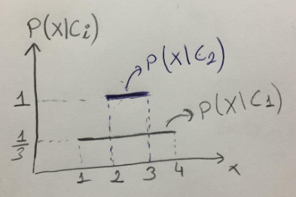

1. 10pts - Develop a classification strategy for a given x (just looking at the graph – no formula), just complete the sentence(s):

`if x is in the region **[2 , 3]** , I will classify it as **C2**;

if x is in the region **[1, 2) U (3, 4]** , I will classify it as **C1**

**c) 5pts -** **Draw the decision regions on the above figure.**

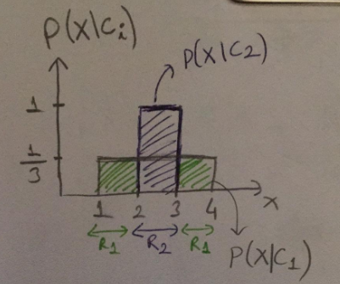

**R1 = [1, 2) U (3,4] classify as C1 and R2 = [2, 3] classify as C2**

**d) 10pts –** Give a **one line qualitative answer** (no precise numbers/threshold**s...)** about **how your decision changes or whether it doesn’t.**

* Would your decision strategy change if P(C1)=0.9 and P(C2)=0.1?

YES, **P(x | C1) * P(C1) > P(x | C2) * P(C2)** holds for all values of x in the interval [1, 4]. Thus, I will classify all the regions as C1.

* How about if it was the reverse P(C1)=0.1 and P(C2)=0.9?

**No**, it does not change, in the interval [2, 3] C2 will be still more dominant. Thus, my answer would be same as in the part b.

**3) 40pts –** **NAIVE BAYES**

**a) 15pts – Given that two random variables X and Y are conditionally independent given C, circle True or False** (2pts for each correct answer; -1pts each wrong answer):

* P(X| Y ) = P(X) True / False
* P(X | Y, C ) = P(X | Y) True / False
* P(X , C | Y ) = P(X | Y ) True / False
* P(X ,Y | C ) = P(X | C) P(Y | C) True / False
* P(X ,Y , C ) = P(X | C) P(Y | C) P(C) True / False

**b) 20pts - Using the PlayTennis data given below** (and in the lecture slides), **how would you classify x=(Overcast, Mild, Normal, Strong), using Naive Bayes classifier *without any smoothing*. Show your work** (e.g. indicate class conditional attribute probabilities under the given table in the next page and just transfer them here).

P(Yes| x) = P(Overcast |Yes) * P(Mild | Yes) * P(Normal | Yes)*P(Strong | Yes)*P(Yes) = **16/567**

P(Yes | x) = (4/9) * (4/9) * (1/3) * (2/3) * (9/14) = **16 / 567**

-------------------

P(No| x) = P(Overcast | No) * P(Mild | No) * P(Normal | No) * P(Strong | No) * P(No) = **0**

P (No | x) = 0 * (2/5) * (1/5) * (3/5) * (5/14) = **0**

**Decision: YES**

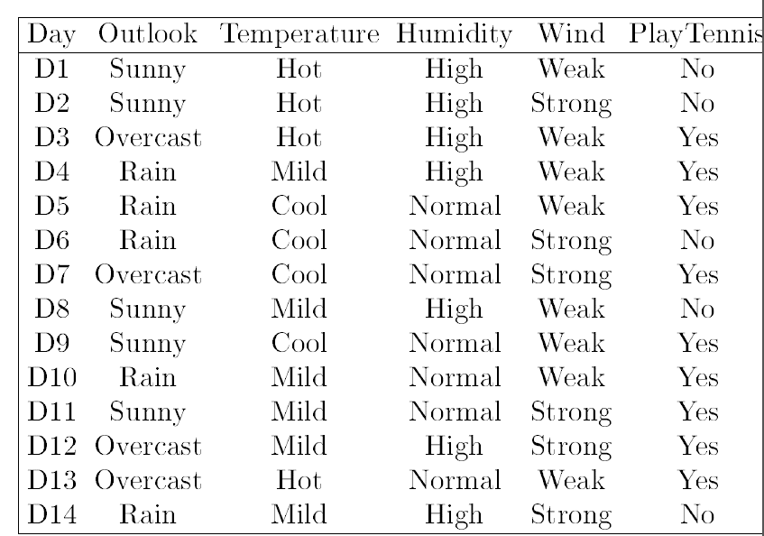

**Write here the estimated probabilities (write those related to the question):**

P(Outlook=**Overcast** | Yes) = **4 / 9**

P(Outlook=**Overcast** | No) = **0**

P(Temperature = **Mild** | Yes) = **4 / 9**

P(Temperature = **Mild** | No) = **2 / 5**

P(Humidity = **Normal** | Yes) = 6 / 9 = **2 / 3**

P(Humidity = **Normal** | No) = **1 / 5**

P(Wind = **Strong** | Yes) = 3 / 9 = **1 / 3**

P(Wind = **Strong** | No) = **3 / 5**

P(**Yes**) = **9 / 14 (Prior Prob)**

P(**No**) = **5 / 14 (Prior Prob)**

P(x | Yes) = P(Outlook=**Overcast** | Yes) * P(Temperature = **Mild** | Yes) * P(Humidity = **Normal** | Yes) * P(Wind = **Strong** | Yes)

P(x | Yes) = (4/9) * (4/9) * (2/3) * (1/3) = **32 / 729**

P(x | No) = P(Outlook=**Overcast** | No) * P(Temperature = **Mild** | No) * P(Humidity = **Normal** | No) * P(Wind = **Strong** | No)

P(x | No) = **0**

**c) 5pts -** Indicate the values **for only the following probabilities** estimated during Naive Bayes training, **using Laplace smoothing:**

**alpha = 1;**

P(Outlook=Overcast|No) = (0 + 1) / (5 + 3) = **1 / 8**

P(Humidity=Normal|Yes) = (6 + 1) / (9 + 2) = **7 / 11**